DRAFT - ICT Project Guidance

Design:  
User Interfaces - Structuring

Version:

0.1

Author:

Sky Sigal, Solution Architect

## Description

<TODO>

## Synopsis

Interfaces are developed as assemblies of nested view components that are categorizable as Containers, which can contain child Containers, as well as Inputs and Output views.

## Contents

Description 1

Synopsis 1

Contents 2

Synopsis 3

Introduction 3

Heading Level 3 3

Heading Level 4 3

Appendices 4

Appendix A - Document Information 4

Images 4

Tables 4

References 4

Review Distribution 4

Audience 4

Structure 4

Diagrams 4

Terms 5

## Purpose

The purpose of this document…

## Introduction

BOSSCARD/ RAID: Background [], Objective, Options, Scope[In/Out], Stakeholders [Users], Constraints, Assumptions, Risks, Dependencies, Decisions, Deliverables.

Purpose

The purpose of interfaces is to provide to end users information as to their context (where they are), the state of relevant systems and resources, and one or more resource.

## Types of Interface View Components

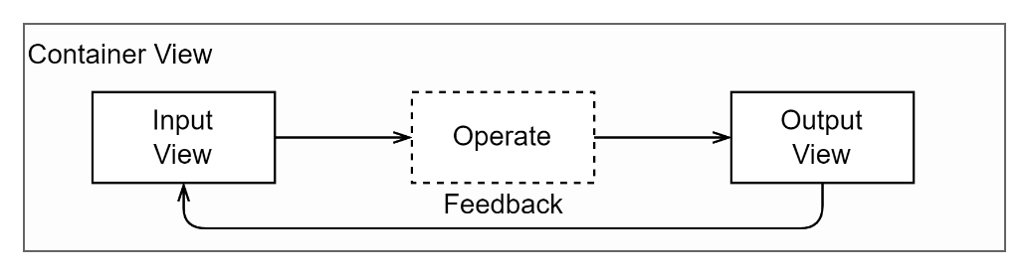

Figure : Interface View Component Types

Interfaces are developed as assemblies of nested view components that are categorizable as Containers, which can contain child Containers, or Input components or Output components.

Note:  
The decoupling of input and output aligns with Separation of Concerns principles, and simplifies maintenance of the service.

Best practice requires that:

* Container components do not contain Input or output controls, only other Container, Input or View components.
* Input containers collect information, but do not present information.
* Output containers present information but do not provide controls to control it.

Appendices

Appendix A - Document Information

### Versions

* 1. Initial Draft

### Images

Figure 1: TODO Image 2

### Tables

Table 1: TODO Table 3

Table 2: TODO Table 2 3

### References

**There are no sources in the current document.**

### Review Distribution

The document was distributed for review as below:

|  |  |
| --- | --- |
| Identity | Notes |
|  |  |
|  |  |
|  |  |

### Audience

The document is technical in nature, but parts are expected to be read and/or validated by a non-technical audience.

### Structure

Where possible, the document structure is guided by either ISO-* standards or best practice.

### Diagrams

Diagrams are developed for a wide audience. Unless specifically for a technical audience, where the use of industry standard diagram types (ArchiMate, UML, C4), is appropriate, diagrams are developed as simple “box & line” monochrome diagrams.

### Terms

Refer to the project’s Glossary.

##### IT

: acronym for Information, using Technology to automate and facilitate its management.

##### ICT

: acronym for Information & Communication Technology, the domain of defining Information elements and using technology to automate their communication between entities. IT is a subset of ICT.